**DNS Server**

**Installing and Configuring the DNS Service**

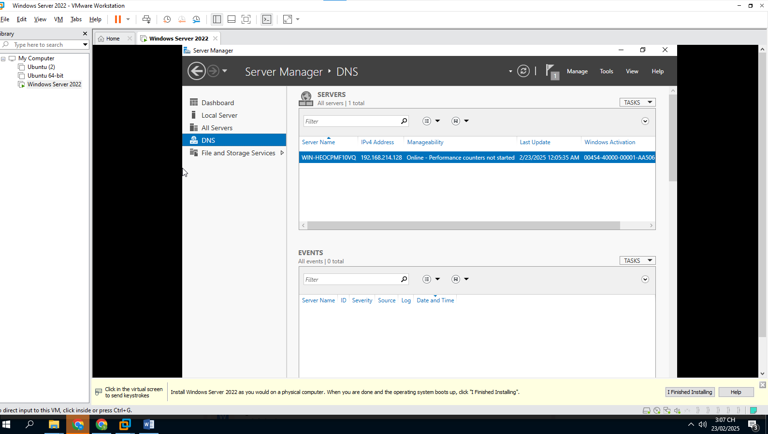

## Configuring a Zone for Dynamic Updates

## 

## 